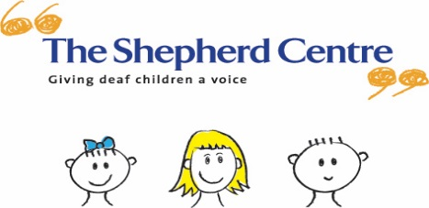
Your Invitation
to celebrate the end of 2017
Thursday 14 December, 10 -12 noon
Santa gifts for our program children will be kindly sponsored by Good360
Santa, face paintings, DrumBeats entertainment, singing, fun and games!
Please bring a wrapped and labelled gift for siblings attending the event

Please bring along a small plate of nut free food to share.
To support variety of food, please bring the following:
Surnames A-H - Adult savory plate
Surnames I-P - Adult sweet plate
Surnames Q-Z - Children’s plate
The event will be held in: Australian Hearing Hub
Level 4 – Jim Patrick room
Please RSVP by Friday Nov 24, to Georgina.McPherson@shepherdcentre.org.au

