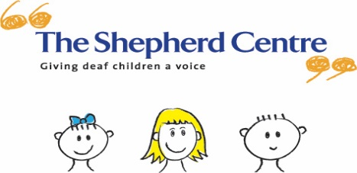
Your Invitation
to celebrate the end of 2017
Tuesday 12 December, 10 -12 noon
Gifts for our program children will be kindly sponsored by ‘Inmost Joy’
Santa, face paintings, DrumBeats entertainment, singing, fun and games!
Please bring a wrapped and labelled gift for siblings attending the event

Please bring along a small plate of nut free food to share.
To support variety of food, please bring the following:
Surnames A-H - Adult savory plate
Surnames I-P - Adult sweet plate
Surnames Q-Z - Children’s plate

Please RSVP by Friday November 24 to: Amy.Nicholson@shepherdcentre.org.au

