`

Dear Professionals

Following the wonderful positive feedback from our Professional Workshops in 2017 along with the early receipt of your expressions of interest for Professional Development for next year, we are delighted to offer a range of workshops in 2018 for professionals working with children with hearing loss. Our official 2018
e-brochure will be distributed in the next fortnight with greater detail of our courses, how to register and how to obtain more information. Below is a summary of the content and dates confirmed so far.

3 major changes in 2018:
- Enrolment on line will be available
- Hosting of our inaugural Twilight Tutorials in mid Term 1 at TSC with leading professionals in our field, e.g., Professor Marc De Rosnay
Enhancing Social/Emotion and Theory of Mind Skills in children with hearing loss.
- Typical social development in 0-7 year olds.
- How can we monitor and assess social development and ToM skills?
- How can we teach and promote social skills and ToM skills.

TERM 1
Understanding Hearing Loss: Tips and tricks for supporting a child with hearing loss in your class
- 2 hour introduction to hearing loss and its effect for preschool/classroom teachers with students with HL integrated into their classroom
- What are the implications of having a hearing loss?
- Practical audiology tips to assist in the classroom
- Top ten practical classroom teaching tips
- What is an FM?
- How can classroom teachers facilitate optimal progress for their students with hearing loss? Identifying and fixing challenges
Friday 2nd February
ACT
Fee: $50 pp
Understanding Hearing Loss: Tips and tricks for supporting a child with hearing loss in your class (as above)
Thursday 22nd February
ACT
Fee: $50 pp

Understanding Hearing Loss: Tips and tricks for supporting a child with hearing loss in your class (as above)
Monday 26th February
Newtown
Fee: $50 pp
Uncurling the Cochlea:
- Understanding cochlear implant candidacy in 2017
- Expectations at the various ages and stages both pre- and post-cochlear implant surgery
- Full-day course suited for professionals working with primary and high school students, infants and children with hearing loss
Monday 9th April
TSC 146 Buren St NEWTOWN
Fee: $250pp includes morning tea, lunch and training manual with multiple re-usable handouts

Uncurling the Cochlea: (as above)
Thursday 12th April
ACT
Fee: $250pp includes morning tea, lunch and training manual with multiple re-usable handouts

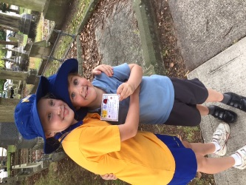
TERM 2
Confident Kids: Enhancing social skills in children with hearing loss, from infancy to school age
- What is Theory of Mind and how can we enhance these skills?
- What is the link between ToM and social skill development?
- Practical Strategies to assist from infancy to high school
- Full-day course suited for professionals working with primary and high school students, infants and children with hearing loss
Monday 7th May
TSC 146 Buren St NEWTOWN
Fee: $250pp includes morning tea, lunch and training manual with multiple re-usable handouts

Confident Kids: Enhancing social skills in children with hearing loss, from infancy to school age
(as above)
Thursday 10th May
ACT
Fee: $250pp includes morning tea, lunch and training manual with multiple re-usable handouts

Let’s Speak About Speech
- Ages and stages of typical speech development
- How does HL impact upon speech development?
- Practise determining appropriate speech goals and programs of remediation for children with HL
- Full-day course suited for professionals working with primary and high school students, infants and children with hearing loss
Monday 2nd July
TSC 146 Buren St NEWTOWN
Fee: $250pp includes morning tea, lunch and training manual with multiple re-usable handouts

Let’s Speak About Speech (as above)
Thursday 5th July
ACT
Fee: $250pp includes morning tea, lunch and training manual with multiple re-usable handouts

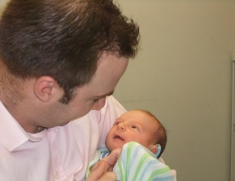

TERM 3
101 Ideas to Climb the Listening and Spoken Language Ladder
- Understand and apply the latest research-based evidence for developing optimal
- Listening, speech, language development techniques
- Full-day course suited for professionals working with primary and high school students, infants and children with hearing loss
Monday 30th July
TSC 146 Buren St NEWTOWN
Fee: $250pp includes morning tea, lunch and training manual with multiple re-usable handouts

101 Ideas to Climb the Listening and Spoken Language Ladder (as above)
Thursday 2nd August
ACT
Fee: $250pp includes morning tea, lunch and training manual with multiple re-usable handouts

Bouncing with Babies: Setting our babies with hearing loss on paths for optimal success
- Best practices for assisting babies with HL in 2018
- Practise determining baby’s functional HL and what steps to take next
- What devices /when?
- Full-day course suited for professionals working with primary and high school students, infants and children with hearing loss
Monday 24th September
TSC 146 Buren St NEWTOWN
Fee: $250pp includes morning tea, lunch and training manual with multiple re-usable handouts

Bouncing with Babies: Setting our babies with hearing loss on paths for optimal success (as above)
Thursday 27th September
ACT
Fee: $250pp includes morning tea, lunch and training manual with multiple re-usable handouts

All courses are BOSTES/NESA accredited in NSW and TQI accredited in ACT. Full AGBell International accreditation has also been awarded for all courses and combination of courses. Courses are being offered on the respective dates from 8:30am – 4:30pm at The Shepherd Centre, 146 Burren Street, NEWTOWN or online via our secure videoconferencing portal.

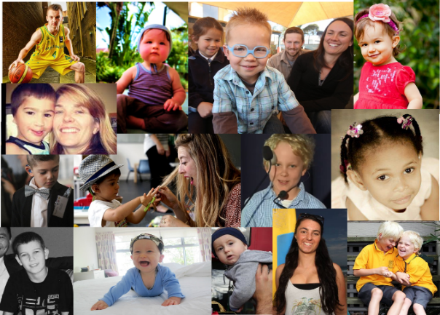

TERM 4
NEW……..
The Magic FLI (Functional Listening Index) [accreditation pending]
- A revolutionary NEW TSC tool to measure and address functional listening skills
- Introduction of on-line tool that can assist both teachers and parents tracking and enhancing skills
- Early enhancement of Functional Listening skills can predict
  - language
  - speech
  - literacy and
  - social skills development
- Full-day course suited for professionals working with primary and high school students, infants and children with hearing loss
Monday 22nd October
TSC 146 Buren St NEWTOWN
Fee: $250pp includes morning tea, lunch and training manual with multiple re-usable handouts

The Magic FLI (Functional Listening Index) (as above)
Thursday 25th October
ACT
Fee: $250pp includes morning tea, lunch and training manual with multiple re-usable handouts

Please feel free to forward this information on to colleagues who may be interested in attending.

Numbers will be limited so it would be advisable to register as soon as possible via email below or on-line registrations available soon.

Alternatively, why not do some team building in your local areas?

We can arrange to come to your region if you can coordinate a group to attend. Minimum of 8 with maximum of 30 participants

Feedback from the 6 outreach workshops we ran in 2016 and 2017 was extremely positive with re-bookings for further workshops for next year, e.g.,

“It’s a much better way to learn than doing on-line courses, greater engagement, chances to ask questions of presenters means sessions can be personalised; materials can be presented and practised”

“Great revision with wonderful new information based on research (3); Practical; interactive; current information, backed by research”

This option is also very cost effective for upskilling all team members without incurring the costs of travelling to Sydney.

If this option appeals to you, please contact Anne Fulcher, Principal Listening and Spoken Language Specialist direct via email: anne.fulcher@shepherdcentre.org.au,
or
Sharon Hill, Manager, Clinical Administration, sharon.hill@shepherdcentre.org.au to discuss the possibilities.

Kind regards,

Anne

