Do you have a child with hearing loss in your class/centre for the first time?

Join world-leading early-intervention providers, The Shepherd Centre, for a NESA, TQI and AGBell session (2 accredited hours) offering practical tips and tricks to support children with hearing loss.

This highly informative session can be available at:
- Your local school for all staff members ( at significantly reduced costs for groups)
- The Shepherd Centre Head Office - 146 Burren Street, Newtown (5 min walk from MacDonaldtown station). Tel: 9370 4402
Time: 9:45 morning tea for 10:00 -12:00 Cost: $50pp Dates announced soon
- The Shepherd Centre, 7 Nealie Place, RIVETT, Tel: 9370 4402
Time: 3:45 afternoon tea for 4:00 – 6:00 Cost: $50pp Dates announced soon
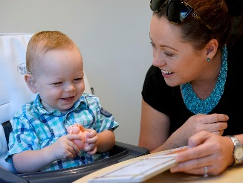

This interactive session will cover:
An Introduction to Hearing Loss (002735): Tips and tricks for supporting a child with hearing loss in your class
- 2 hour introduction to hearing loss and its effect for preschool/classroom teachers with students with hearing loss integrated into their classroom.
- What are the implications of having a hearing loss?
- Practical audiology tips to assist in the classroom.
- Top 10 practical classroom teaching tips.
- What is an FM?
- How can classroom teachers facilitate optimal progress for their students with hearing loss? Identifying and addressing challenges.
Contact:
Dr Anne Fulcher, Principal Listening and Spoken Language Specialist
anne.fulcher@shepherdcentre.org.au
or
Sharon Hill, Manager, Clinical Administration, sharon.hill@shepherdcentre.org.au

