
Tuning in to Kids
& Toddlers
Emotionally Intelligent Parenting

A Six Session Parenting Program

Would you like to learn how to:
- be better at talking with your child?
- be better at understanding your child?
- help your child learn to manage their emotions?
- help to prevent behaviour problems in your child?
- teach your child to deal with conflict?

Tuning in to Kids shows you how to help your child develop emotional intelligence.
Children with higher emotional intelligence:
- have greater success with making and keeping friends
- have better concentration at school
- are more able to calm down when upset or angry

- tend to have fewer childhood illnesses
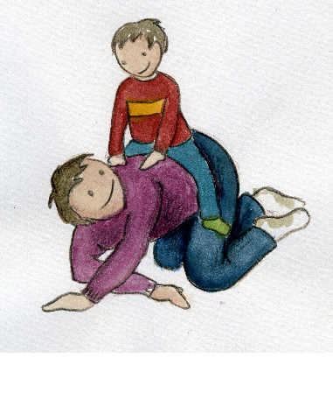
Where: Liverpool Centre
When: from Wednesday 25 October for 6 weeks
Time: 10.30am to 12pm
Registration: by Friday 13 October via
Email: stephanie.ingram@shepherdcentre.org.au
Telephone 9370 4415
Contact: Stephanie Ingram, Child and Family Counsellor

